TAREA 3

CARLOS CABALLERO

4-790-1806

1 – Para el circuito inferior detalle lo siguiente:

* Utilice DeMorgan para encontrar su equivalente
* Escriba la ecuación lógica
* Escriba la tabla de la verdad

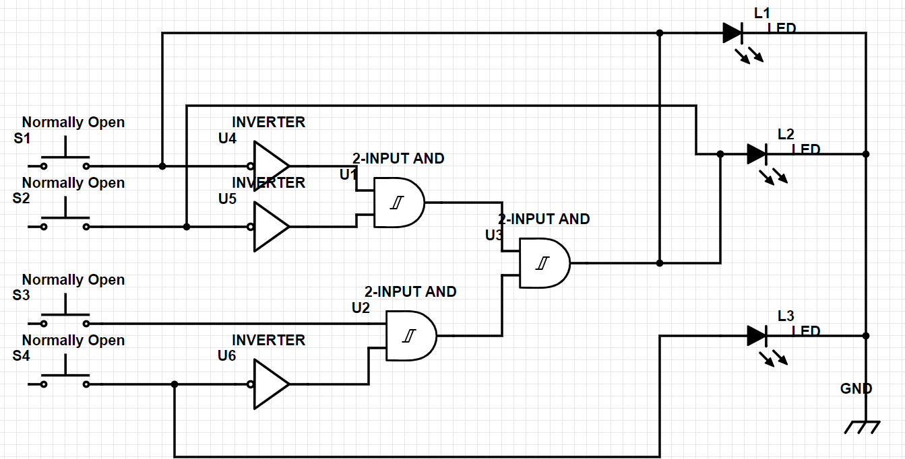

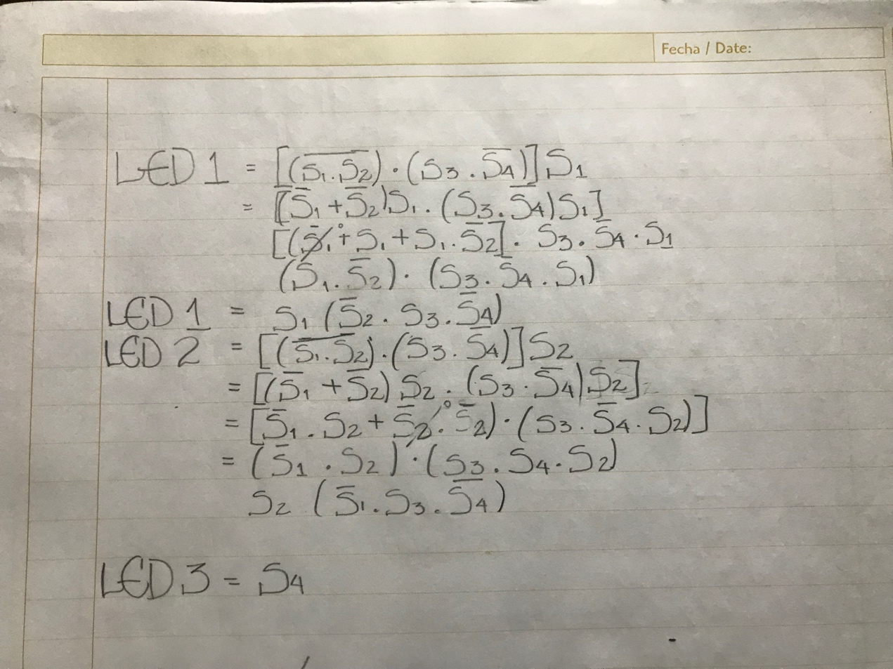

***TABLA DE LA VERDAD***

|  |  |  |  |  |  |  |
| --- | --- | --- | --- | --- | --- | --- |
| A | B | C | D | L1 | L2 | L3 |
| 0 | 0 | 0 | 0 | 0 | 0 | 0 |
| 0 | 0 | 0 | 1 | 0 | 0 | 1 |
| 0 | 0 | 1 | 0 | 1 | 1 | 0 |
| 0 | 0 | 1 | 1 | 0 | 0 | 1 |
| 0 | 1 | 0 | 0 | 1 | 1 | 0 |
| 0 | 1 | 0 | 1 | 1 | 1 | 1 |
| 0 | 1 | 1 | 0 | 1 | 1 | 0 |
| 0 | 1 | 1 | 1 | 1 | 1 | 1 |
| 1 | 0 | 0 | 0 | 1 | 1 | 0 |
| 1 | 0 | 0 | 1 | 1 | 1 | 1 |
| 1 | 0 | 1 | 0 | 1 | 1 | 0 |
| 1 | 0 | 1 | 1 | 1 | 1 | 1 |
| 1 | 1 | 0 | 0 | 1 | 1 | 0 |
| 1 | 1 | 0 | 1 | 1 | 1 | 1 |
| 1 | 1 | 1 | 0 | 1 | 1 | 0 |
| 1 | 1 | 1 | 1 | 1 | 1 | 1 |

***ECUACIONES DE CADA SALIDA (L1, L2, L3)***

|  |  |  |  |  |
| --- | --- | --- | --- | --- |
| AB/CD | 00 | 01 | 11 | 10 |
| 00 |  |  |  | 1 |
| 01 | 1 | 1 | 1 | 1 |
| 11 | 1 | 1 | 1 | 1 |
| 10 | 1 | 1 | 1 | 1 |



***L1 = A + B +***

|  |  |  |  |  |
| --- | --- | --- | --- | --- |
| AB/CD | 00 | 01 | 11 | 10 |
| 00 |  |  |  | 1 |
| 01 | 1 | 1 | 1 | 1 |
| 11 | 1 | 1 | 1 | 1 |
| 10 | 1 | 1 | 1 | 1 |

***L2 = A + B +***

|  |  |  |  |  |
| --- | --- | --- | --- | --- |
| AB/CD | 00 | 01 | 11 | 10 |
| 00 |  | 1 | 1 |  |
| 01 |  | 1 | 1 |  |
| 11 |  | 1 | 1 |  |
| 10 |  | 1 | 1 |  |



***L3 = D***

Problemas 2 y 3: Resuelva 1 de 2

2 – Encuentre el diagrama lógico de la siguiente expresión (no simplificar).

Nota: Puede dibujarlo si gusta con <https://www.digikey.com/schemeit>

3. Para la siguiente tabla de verdad encuentre la ecuación de suma de productos (Salida = O). (No simplificar)

|  |  |  |  |
| --- | --- | --- | --- |
| X | Y | Z | **O** |
| 0 | 0 | 0 | **1** |
| 0 | 0 | 1 | **1** |
| 0 | 1 | 0 | **0** |
| 0 | 1 | 1 | **0** |
| 1 | 0 | 0 | **1** |
| 1 | 0 | 1 | **1** |
| 1 | 1 | 0 | **0** |
| 1 | 1 | 1 | **1** |

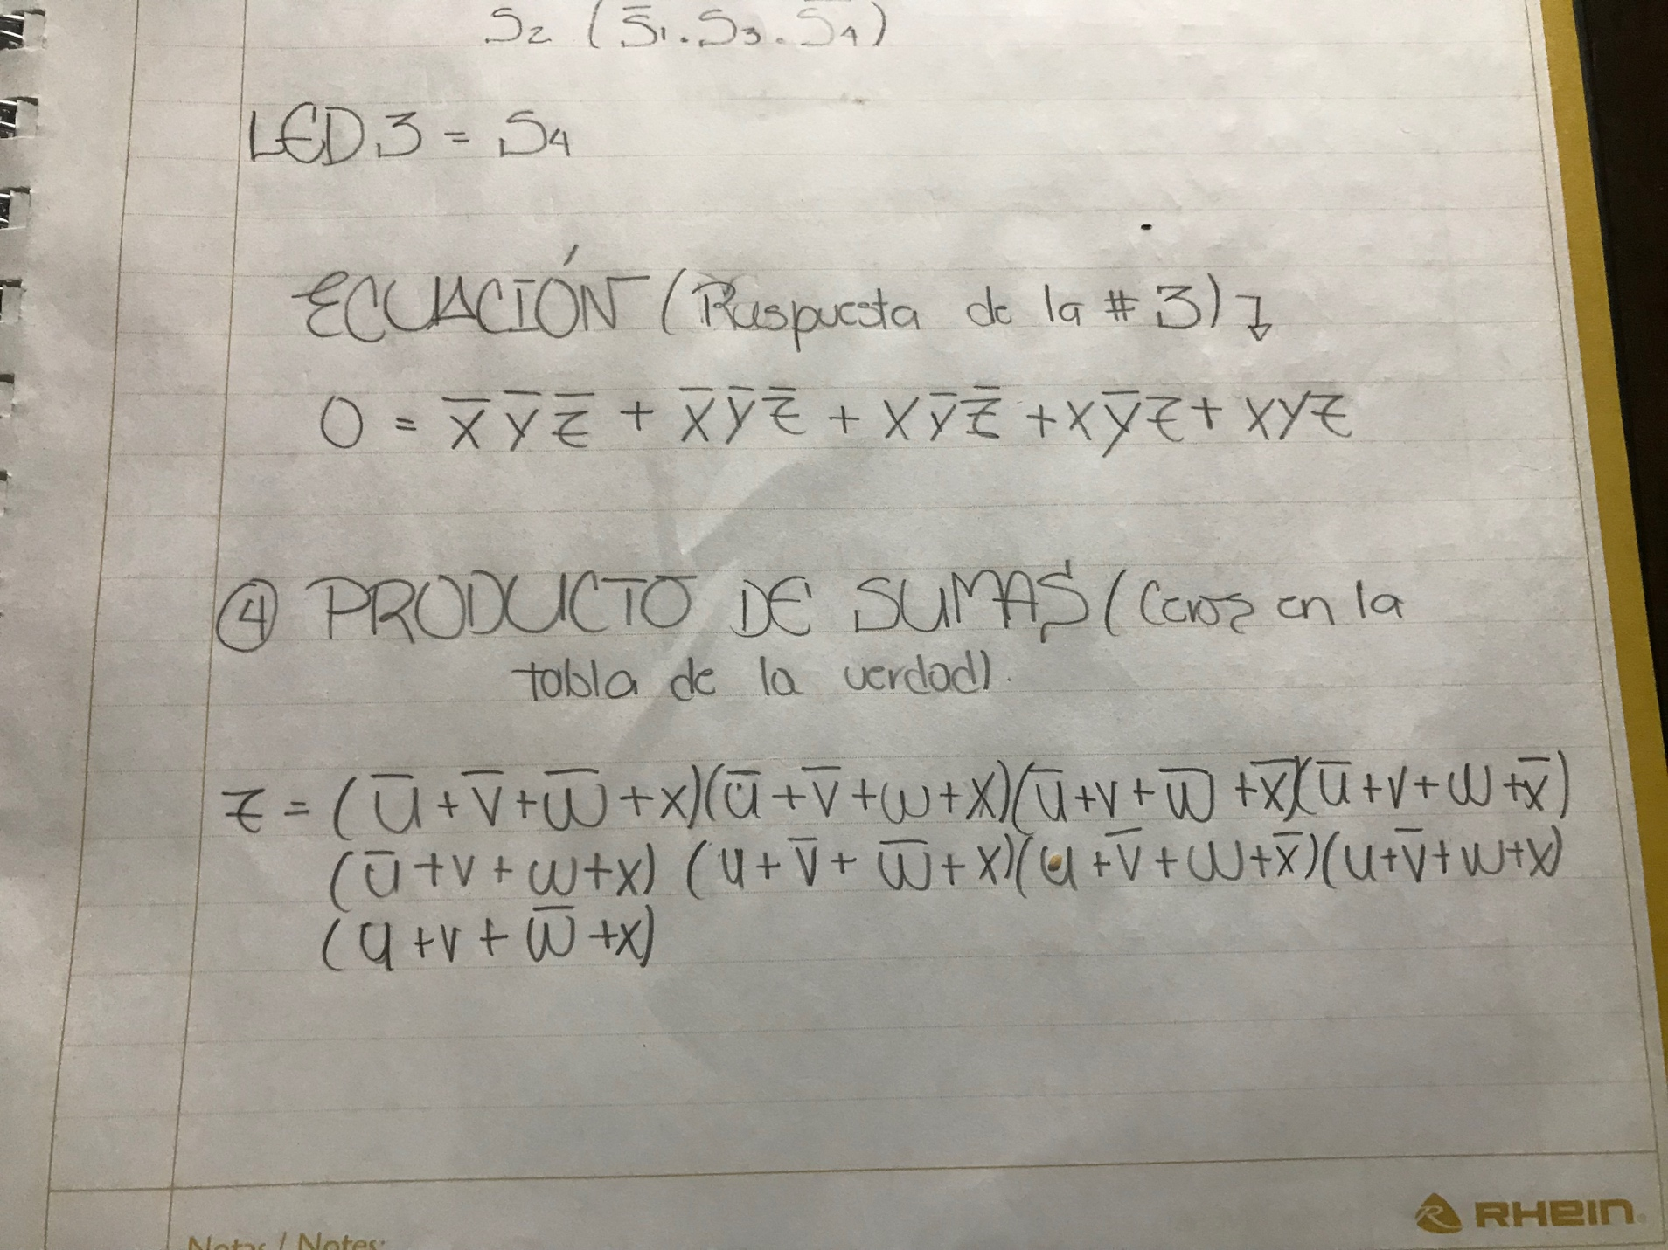

Problemas del 4 al 6: Resuelva 2 de 3

4. Para la siguiente tabla de verdad encuentre la ecuación en productos de suma (Salida = Z). (No Simplificar).

|  |  |  |  |  |
| --- | --- | --- | --- | --- |
| U | V | W | X | **Z** |
| 0 | 0 | 0 | 0 | **1** |
| 0 | 0 | 0 | 1 | **0** |
| 0 | 0 | 1 | 0 | **1** |
| 0 | 0 | 1 | 1 | **0** |
| 0 | 1 | 0 | 0 | **0** |
| 0 | 1 | 0 | 1 | **1** |
| 0 | 1 | 1 | 0 | **0** |
| 0 | 1 | 1 | 1 | **0** |
| 1 | 0 | 0 | 0 | **1** |
| 1 | 0 | 0 | 1 | **0** |
| 1 | 0 | 1 | 0 | **0** |
| 1 | 0 | 1 | 1 | **0** |
| 1 | 1 | 0 | 0 | **1** |
| 1 | 1 | 0 | 1 | **0** |
| 1 | 1 | 1 | 0 | **1** |
| 1 | 1 | 1 | 1 | **1** |

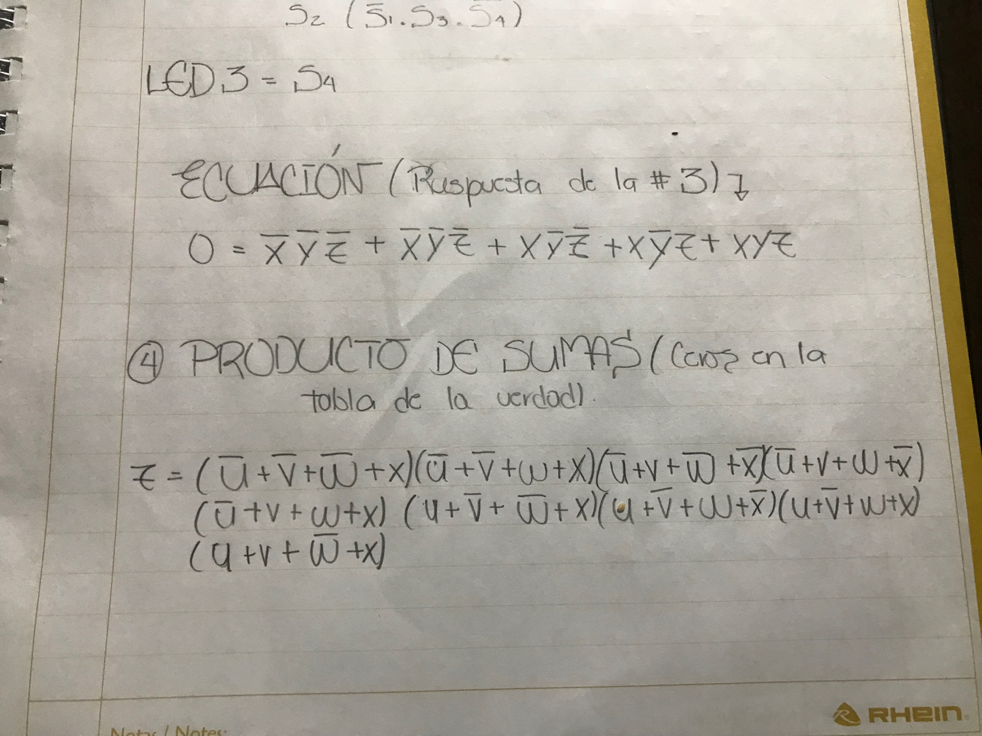

5. Use algebra booleana para simplificar las siguiente expresión:

6. Use reglas de simplificación para algebra booleana y por medio de mapa de Karnaugh encuentre la suma de productos de:

|  |  |  |  |  |
| --- | --- | --- | --- | --- |
| A | B | C | D | **Y** |
| 0 | 0 | 0 | 0 | **1** |
| 0 | 0 | 0 | 1 | **1** |
| 0 | 0 | 1 | 0 | **1** |
| 0 | 0 | 1 | 1 | **1** |
| 0 | 1 | 0 | 0 | **1** |
| 0 | 1 | 0 | 1 | **0** |
| 0 | 1 | 1 | 0 | **1** |
| 0 | 1 | 1 | 1 | **0** |
| 1 | 0 | 0 | 0 | **1** |
| 1 | 0 | 0 | 1 | **1** |
| 1 | 0 | 1 | 0 | **0** |
| 1 | 0 | 1 | 1 | **0** |
| 1 | 1 | 0 | 0 | **0** |
| 1 | 1 | 0 | 1 | **0** |
| 1 | 1 | 1 | 0 | **0** |
| 1 | 1 | 1 | 1 | **0** |

7. Resuelva el siguiente problema utilizando Productos de suma y el mapa de Karnaugh

|  |  |  |  |  |
| --- | --- | --- | --- | --- |
| A | B | C | D | **Y** |
| 0 | 0 | 0 | 0 | **0** |
| 0 | 0 | 0 | 1 | **X** |
| 0 | 0 | 1 | 0 | **1** |
| 0 | 0 | 1 | 1 | **0** |
| 0 | 1 | 0 | 0 | **X** |
| 0 | 1 | 0 | 1 | **1** |
| 0 | 1 | 1 | 0 | **0** |
| 0 | 1 | 1 | 1 | **X** |
| 1 | 0 | 0 | 0 | **1** |
| 1 | 0 | 0 | 1 | **0** |
| 1 | 0 | 1 | 0 | **1** |
| 1 | 0 | 1 | 1 | **X** |
| 1 | 1 | 0 | 0 | **0** |
| 1 | 1 | 0 | 1 | **1** |
| 1 | 1 | 1 | 0 | **X** |
| 1 | 1 | 1 | 1 | **X** |

